  
  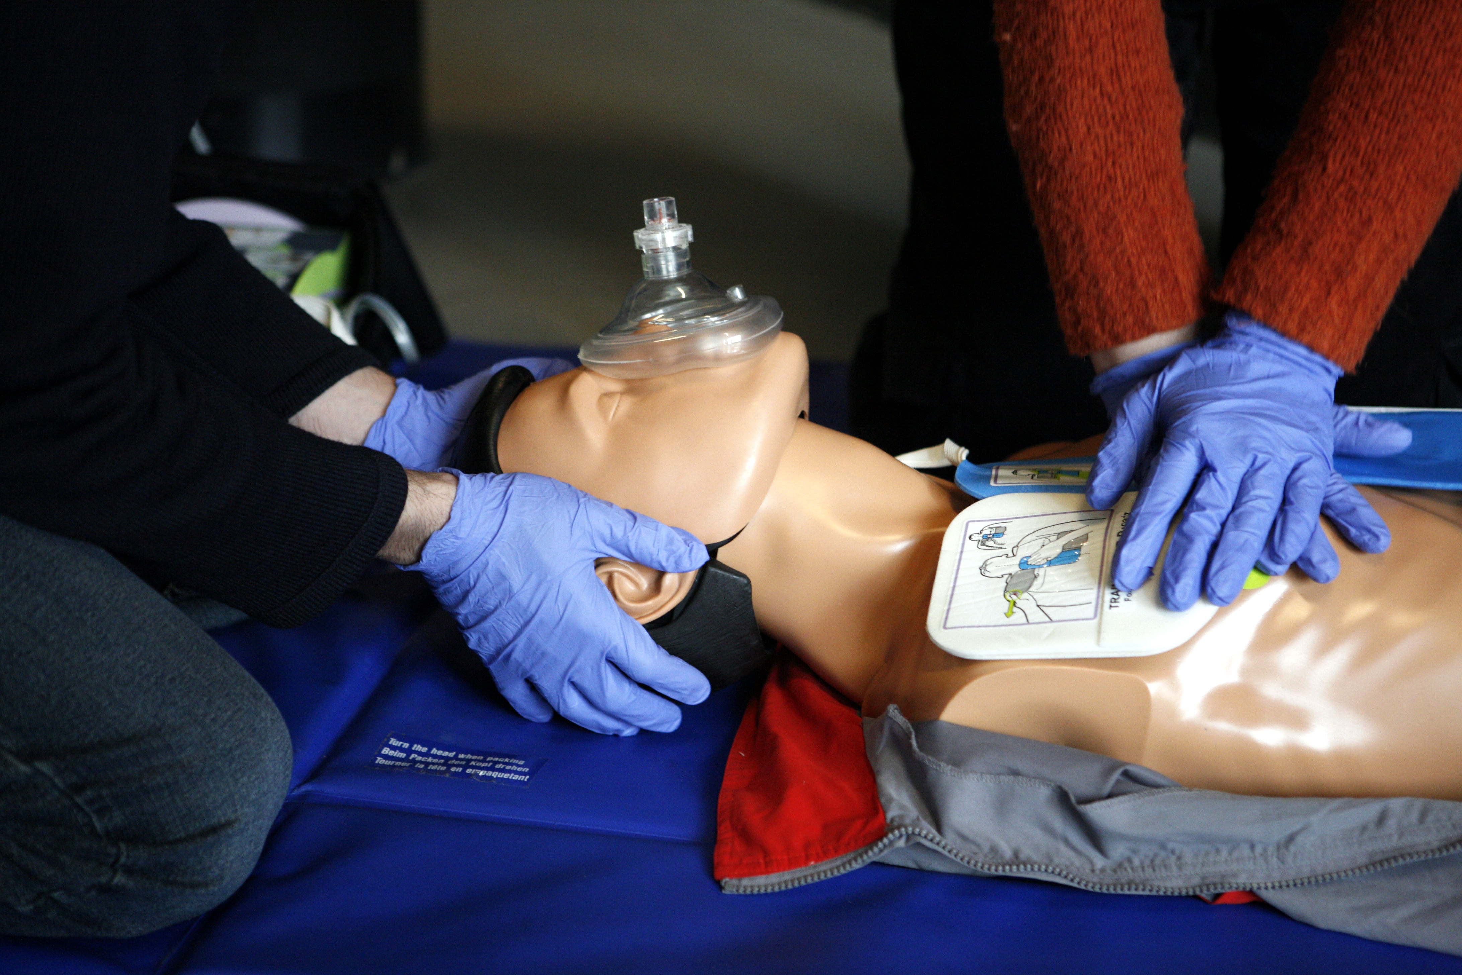
    - Adult first aid/cpr/aed training
  The Adult First Aid/CPR/AED course incorporates the latest science and teaches students to recognize and care for a variety of first aid emergencies such as burns, cuts, scrapes, sudden illnesses, head, neck, back injuries, heat and cold emergencies and how to respond to breathing and cardiac emergencies for victims about 12 years and older. Successful students will receive a certificate for Adult First Aid/CPR/AED valid for two years.
  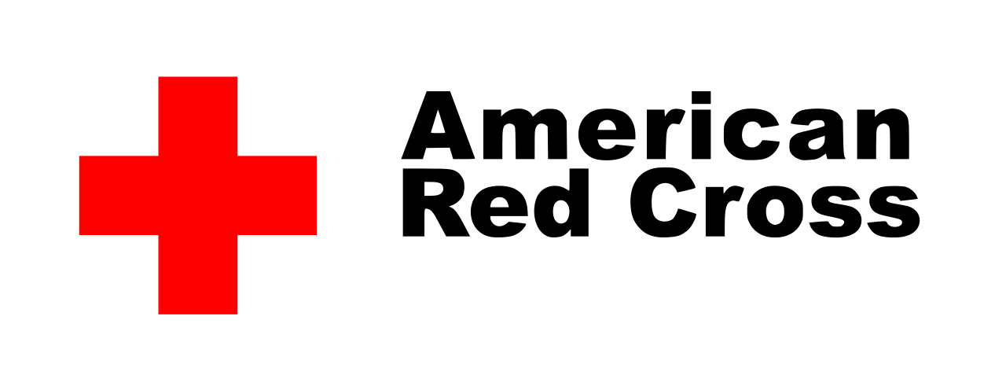
  655555
  classes held 2nd saturday each month
  F
  10:00 am – 3:00 pm
  $65.00 per person
  Sherry Ferebee, instructor
  To
  
  to register call 757-962-9786
  4663 Haygood Road, Suite 201
  Virginia Beach, VA 23455
  For more information please visit
  www.virginiasupportgroup.org

