

Contact Us Today!!

Our highly trained staff has:

- CPR/First Aid certification
- Medication Management certification (32 hour course)
- Human Rights –Abuse & Neglect Prevention
- Recognition & Intervention training
- Behavior support certification
- Clearance through criminal background investigation and drug testing
- Compliance with Virginia Licensing Training requirements
- Annual DMV record review and Defensive Driving Training

Virginia Support Group Day Support Program is licensed by the Virginia Department of Behavioral Health and Developmental Services and affiliated with a local human rights committee.
Virginia Support Group, LLC
5227 Cleveland Street
Virginia Beach, VA 23462
www.virginiasupportgroup.org

Email: admissions@virginiasupportgroup.org

Phone: 757-927-3730
Fax: 757-248-2126

Virginia Support Group
Staff
“Supporting and connecting people and community through service”

Virginia Support Group, LLC
Day Support Service


Admissions

About Us

Program Services
Admission Criteria

To be eligible for services, an individual must:
- Be 18 years or older
- Be eligible for Medicaid, meet the Level of Functioning Survey criteria, have a diagnosis of Intellectual Disability/Mental Retardation (ID/MR), and an ID/MR waiver.
- Meet program description requirements.
- Have no significant medical conditions that require invasive procedures
- Fit into the program’s staff ratio structure

Admission Procedure

Please call Sherry Ferebee, our Program Director at 757-927-3730 or email at admissions@virginiasupportgroup.org to receive an application for services or arrange a program tour.

Once a completed application packet is received, an intake assessment will be conducted with the individual, case manager, and authorized representative.

Applicants will be approved if space is available and they meet eligibility requirements.

- Community Integration
- Social Skills
- Cultural Activities
- Self-Care Skills
- Health and Safety Skills
- Positive Behavior Support
- Resources Familiarization
- Relationship Building
- Person-Centered Planning
- Household Skills
- Communication Skills
- Medication Management
- Problem Solving Skills
- Therapeutic Recreation

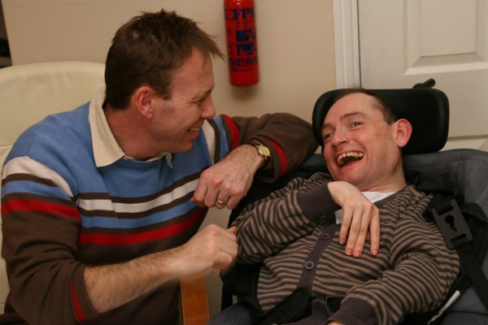

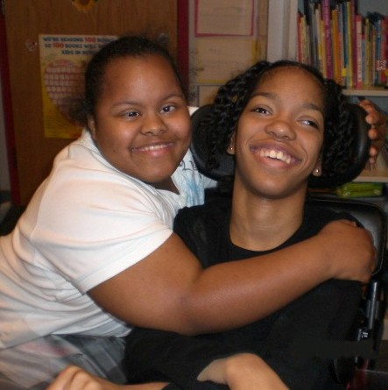

Virginia Support Group, LLC (VSG) provides a constellation of activities for adults who have challenges related to intellectual disabilities. The day support program is designed to provide a minimum of six hours per weekday of comprehensive habilitation training based on their personal preferences as outlined in their Individualized Service Plan (ISP). The ISP uses Person-Centered Planning to develop individualized activities, support, training and supervision to assist individuals in maintaining or improving their placement in the community. Examples of Day Support Center features include, but are limited to:
- Computer Lab with safe internet connectivity
- Music Room
- Nature Center
- Art and Craft Area
- Wellness Room
- Projector for movies
- Games and Puzzle Center
- Holiday parties

Features

