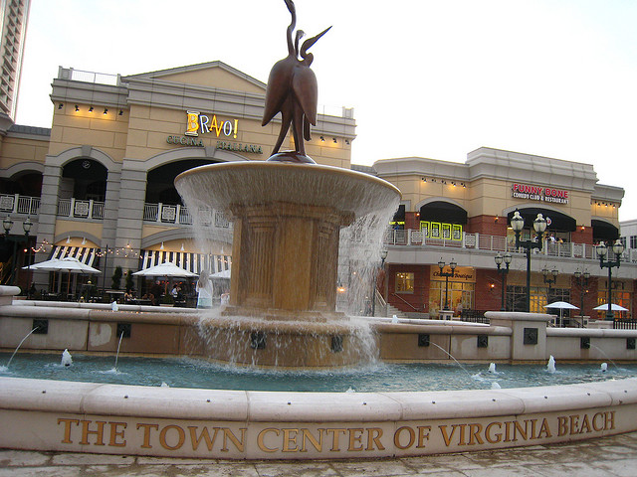  Virginia Beach Town Center  Contact Us  Phone: 757-648-1210 (House)  757-962-9826 (Office)  Email: admissions@virginiasupportgroup.org  Web: www.virginiasupportgroup.org  Virginia Support Group, LLC Residential Program |  |  | Virginia Support Group, LLC |  | Virginia Support Group, LLC  Virginia Support Group, LLC | Residential Program  Supporting and connecting people and community through service.  
  608 Aragona Blvd
  Virginia Beach, Virginia 23462
  Our highly trained staff has:
  - CPR/First Aid certification
  - Medication Management certification (32 hour course)
  - Human Rights –Abuse & Neglect Prevention
  - Recognition & Intervention training
  - Behavior support certification
  - Clearance through criminal background investigation and drug testing
  - Compliance with Virginia Licensing Training requirements
  - Annual DMV record review and Defensive Driving Training
  Virginia Support Group Day Support Program is licensed by the Virginia Department of Behavioral Health and Developmental Services and affiliated with a local human rights committee.
  Virginia Support Group Day Support Program is licensed by the Virginia Department of Behavioral Health and Developmental Services and affiliated with a local human rights committee.

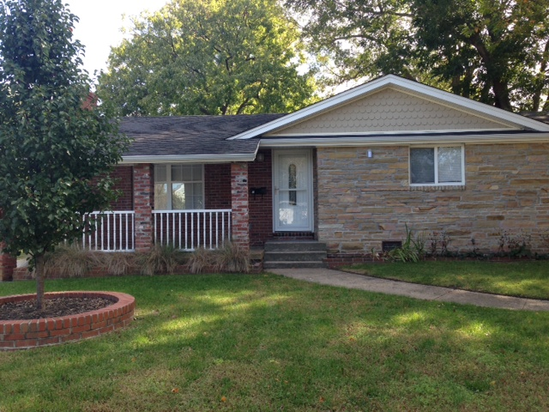  What We Do  Virginia Support Group, LLC Residential Program provides a constellation of activities for adults who have challenges related to intellectual disabilities. The residential program provides continuous training and support in an atmosphere of encouragement, fun, and creativity. Primary activities include development and enhancement of independent living skills through activities such as art, technology, communication, socialization, special projects, and community integration. These activities will encourage support and empower individuals to enhance their daily living skills, personal growth, and quality of life in areas of community living. |  |  | Mission Statement  The mission of Virginia Support Group, LLC Residential Program is to provide a loving, caring, effective nurturing and safe home for adults with intellectual and developmental disabilities. Virginia Support Group, LLC Residential Program will provide a comprehensive, person-centered planning to enhance the quality of life for each individual we provide support and assistance. Virginia Support Group, LLC Residential Program will also provide clean, healthy, and therapeutic environment in which the individual optimizes their level of functioning and will obtain normalization in their lives. Clients will be encouraged to make individual choices and maintain a positive relationship with their family and the community.  Philosophy  Virginia Support Group, LLC Residential Program will affirm the rights of adults with intellectual and developmental disabilities to live and be fully included in the community as participating and contributing members of society. Each individual in the group home is supported through responsive Person-Centered Planning. Through Person-Centered Planning each individual is encouraged to be as independent as possible by providing the necessary supports to allow each person to pursue their life goals and to enhance existing skills.  Individuals entering the program are given the opportunity and supports to learn skills necessary for a positive transition into the community and/or maintaining acquired skills for successful community living.  The philosophy further affirms that the support staff at Virginia Support Group, LLC Residential Program be trained and supported in Person Centered Planning, Human Rights, Documentation, Plan Implementation and other ways that best support the individuals in the Residential Program. |  |  | the necessary supports to allow each person to pursue their life goals and to enhance existing skills.  Program Services  - Community Integration  - Social Skills  - Cultural Activities  - Self-Care Skills  - Health and Safety Skills  - Positive Behavior Support  - Resources Familiarization  - Relationship Building  - Person-Centered Planning  - Household Skills  - Communication Skills  - Medication Management  - Problem Solving Skills  - Therapeutic Recreation  Admission Procedure  Please contact Sherry Ferebee, Executive Director at 757-648-1210/ 757-962-9786 or by email at admissions@virginiasupportgroup.org to receive an application for services or arrange a program tour.  Applicants will be approved if space is available and they meet eligibility requirement.

